Dikshya Kafle_2018380039 Research Training

## Ember: Energy Management of Batteryless Event Detection Sensors with Deep Reinforcement Learning

**CCS CONCEPTS:**

• Computer systems organization→ Sensor networks;

• Computing methodologies → Reinforcement learning.

**KEYWORDS**

Batteryless, Event-Driven Sensing, Deep Reinforcement Learning

**Goal:**

-To maximize event detention

**Purpose:**

-Seek solution that can adapt to environmental changes over time.

**Overview:**

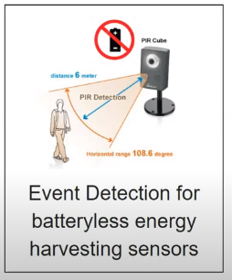

Energy management can extend the life of batteryless, energy harvesting systems by judiciously using available resources. Batteryless sensors resist battery replacement at the cost of slowing or stopping their operations when there is insufficient energy to harvest in the field. Although this approach can work for some applications, due to the transient nature of events and the unpredictability of energy supply, event-based applications remain a challenge.One alternative for both detecting the incident and conserving energy is to switch on a sensor right before it happens. As a result, the system must be able to predict events with confidence while still monitoring resource availability.

As shown in this paper, their device learns environmental patterns over time and makes decisions to optimize the event detection rate for batteryless energy-harvesting sensor nodes with low energy availability. In addition, this paper shows how Ember can identify new environmental patterns over time using a novel self-supervised data collection algorithm.

**Introduction:**

* The paper presents a system called Ember: reinforcement-learning system aiding in learning sensing patterns for battery-free autonomous indoor wireless sensing mote.
* The learning process is bases on a well-cited algorithm presented already online ("Proximal policy optimization algorithms").
* The objective of the system presented in this submission is to minimize missed sensing events while maximizing the life-time of the battery-free sensor. The system has been evaluated on a real custom battery-free sensor (together with a back-end system for learning and simulations) and very extensively evaluated in a very realistic indoor scenario.

**Proposal:**

* Ember is a low-energy energy management framework focused on deep reinforcement learning for duty cycle event-driven sensors.
* They use historical real-world data traces of motion, temperature, humidity, pressure, and light events to train the policy.
* Without depleting the node, the resulting policy will learn to capture up to 95% of the events.
* They suggest a self-supervised mechanism to collect ground-truth data while simultaneously learning from the data while deploying a node at a new location without historical data for training.
* Ember learns to catch the majority of events without any historical data in a week and matches the output of policies trained with historical data in a few weeks.
* They used Ember on 40 nodes to show that the learned policies generalize to real-world settings and outperform state-of-the-art techniques.

**Problems and Analysis:**

1. **Application Specific:** Application-specific indoor sensor node systems have been proposed that use energy harvesting [63, 79, 30, 82, 126]. Xiang et al. use piezoelectric harvesting to sense the airflow [63], DoubleDip is for water flow sensing [82], Monjolo is for power sensing [30]. The company EnOcean [126] produces battery-less systems for lighting, temperature, or electric load control, but each sensor node design is application-specific. We focus on a generic design that can be reused for most applications. Some works have proposed energy harvesting for wearables [79], our indoor sensing requirements differ widely from wearables.
2. **Energy Harvesting + Rechargeable Battery:** The combination of energy harvesting and rechargeable batteries can be used to achieve a long lifetime. Prior works have used power management techniques to maximize the lifetime for such nodes [79, 30]. However, the life of rechargeable batteries is limited to a few hundred cycles [10], and limits the overall lifetime. Hence, recent works and our platform exploit the use of super-capacitors as they can support up to a million charging cycles [95].
3. **Communication Protocol:** Another major limitation of prior energy harvesting works is that most of them do not support standard communication protocols such as ZigBee or BLE since they require more energy to sustain a communication protocol [18, 82]. But to facilitate interoperability with existing technologies, we set this as a requirement for indoor sensors. The works that do adopt standard protocols [110, 17, 126, 48], either do not consider perpetual operations or are built for specific applications. As an example [126], pushing on rocker switches, generates just enough piezo-electrical energy to broadcast a 128-bit “telegram” to radio modules inside light fixtures, electrical outlets, or control hubs. But these systems require an interaction with the user to generate energy, which is not feasible for applications that require periodical ambient sensing.
4. **Intermittent:** Campbell et al. [18] designed an indoor sensor-node for light, airflow, and door monitoring that exploit piezo-film vibration and light to store energy in a bank of capacitors. To limit the size and facilitate deployment, the system stores only the amount of energy needed for reading and transmitting a single sensor data packet. In this way, the system is continuously working when light is available in the environment but it stops during dark periods. While useful for some applications such as sensing light availability, their solution is limited when energy availability is low. For example, their results show that door-open detection can achieve only 66% accuracy due to the slow recharging of the capacitors. Hester et al [48, 47], present a platform for quickly prototyping battery-less embedded sensors. Using a modular “plug and play” architecture, their system supports a wide range of energy harvesting solutions and sensors. The system exploits a federated energy storage architecture [47] (i.e. many and small super-capacitors instead of a big single one) that allows for programs up to 10% more computational availability, but no considerations are reported for perpetual operation and the system functionality is intermittent.
5. **Power Management:** Several papers [66, 88] underline the importance of having a power management that balance sensing, computation, communication, and energy availability to achieve energy-neutral operations. But these techniques use heuristics to make prediction of the future energy availability and adapt the application performance accordingly. As a results those methods are not scalable for large-scale deployment of these devices limiting their applications in the real-world. We use Reinforcement Learning (RL) [113] techniques to learn environmental patterns and implement a strategy that uses the resource available to satisfy the application requirements. In RL, while the definition of the problem is generic and can be easily extended to a variety of applications/platforms, the strategy calculated is specific for the environment in which the sensor-node is deployed. Many recent works [106, 29, 5, 54, 55, 56, 128, 21, 31, 77] exploit reinforcement learning to automatically optimize the operation of sensor nodes under uncertain energy availability. However these works are simulation-based and do not consider realistic deployment conditions and environmental changes over time.

**Problems:**

The key challenge lies in learning an effective policy to decide when to power the sensors. Real-world events are not perfectly predictable, and thus the policy needs to trade-off between capturing events and depleting energy available. As the available energy and event patterns change across environments, we need to learn a data-driven policy that adapts to the environment. Recent works have proposed a reinforcement learning (RL)-based approach to learn such policies for energy-harvesting sensors [22, 46].

-An additional challenge is that historical events data is required for learning a data-driven policy.

- They build a device that maximizes the amount of events that can be registered while preventing the sensor node's resources being drained due to intermittent and unpredictable energy availability.

-Ember is an energy management methodology that employs deep reinforcement learning to learn energy availability and event patterns in the environment, as well as respond to evolving trends.

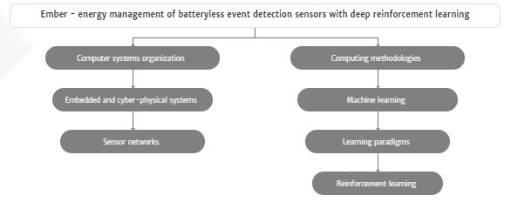

**What is the problem the paper solves?**

-Batteryless sensors avoid battery replacement at the cost of slowing down or stopping their operations when there is not sufficient energy to harvest in the environment. While this approach can work for some applications, event-based applications remain a challenge due to the intermittent nature of events and the unpredictability of energy availability.

-To run event-driven applications on batteryless energy harvesting nodes, the device must carefully preserve energy by turning on the sensors just before the events occur. As a result, the most difficult task is determining an appropriate strategy for deciding when to power the sensors. Since real-world events are not perfectly predictable, the strategy must strike a balance between catching events and depleting the available energy.

-They had to change batteries on a regular basis during their tests, and many of their findings were spoiled by the lack of access to the building due to the Covid-19 pandemic-induced shutdown.

-After just a few weeks of testing, they were able to replace 27 coin-cell batteries with 16 battery-powered nodes, as the batteries only lasted about a month. This personal experience highlights the difficulties of depending on batteries to power IoT devices.They hope that their work will enable the adoption of batteryless, energy-harvesting systems as well as more study.

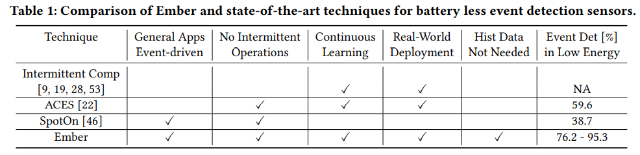

The difference of the work from prior works is summarized in Table 1, which is helpful for readers (and reviewers) to understand the novelty and the contribution(s) of the work. The proposed technique called Ember has been implemented and tested through real-world experiments.

**Why is the problem important?**

By 2025, the Internet of Things industry is estimated to have risen to over 75 billion connected devices. Many of these devices are battery-powered and need manual maintenance to stay operational, rendering them neither cost-effective nor scalable.

Internet of Things forms the backbone of modern building applications. Wireless sensors are being increasingly adopted for their flexibility and reduced cost of deployment. However, most wireless sensors are powered by batteries today and large deployments are inhibited by manual battery replacement. Energy harvesting sensors provide an attractive alternative, but they need to provide adequate quality of service to applications given uncertain energy availability.

Energy harvesting sensors are an appealing option, but given the uncertainty of energy supply, they must provide adequate quality of service to applications. In this paper, reinforcement learning is proposed as a method for optimizing the process of energy harvesting sensors in order to improve sensing efficiency while conserving energy.

As available energy and event dynamics change across ecosystems, we must learn a data-driven approach that adapts to the climate. A reinforcement learning (RL)-based approach to learning energy-harvesting sensor policies has recently been suggested.

ACES uses a Q-learning algorithm for duty cycle sensors, but they only learn about energy availability patterns in the atmosphere and treat event sensors like periodic sensors. As a result, they are unable to adapt their learned approach to changing environmental conditions. Spot ON often employs Q-learning to predict both events and energy supply.

Their tabular method, on the other hand, restricts the number of inputs they can use for prediction, resulting in a low detection accuracy of 19%. Another issue is that learning a data-driven policy necessitates historical event data.

**What is the proposed solution?**

To fix these issues, they built a device that maximizes the amount of events that can be registered while preventing the sensor node's resources being drained due to intermittent and volatile energy availability. To this end, they present Ember, an energy management strategy that utilizes deep reinforcement learning to learn energy availability and event patterns in the environment, as well as to respond to evolving trends.

**How well does the solution work?**

-Ember is a deep reinforcement learning-based energy management framework for event detection with batteryless sensors.

- They tested Ember using real-world data traces, demonstrating that it can identify environmental event patterns and monitor motion, temperature, humidity, pressure, and light sensors to capture environmental events using ambient light energy harvesting.

- When there is no historical data to practice with, they introduced a self-supervised ground-truth data collection mechanism that aids the machine in finding new events.

- As they announce the results of a 40-node wireless sensor network implementation in an office building, they tested their device in both simulations and real-world experiments.

- Ember outperforms previous approaches, catching up to 27% more events than state-of-the-art techniques while preventing energy storage degradation in a variety of indoor lighting conditions, according to the report.

- They want to investigate the use of data obtained by multiple nodes to speed up the learning of newly deployed sensor nodes in the future.

**Summary:**

* This paper presents a design of the system that can capture as many events as possible while avoiding the depletion of the sensor node's energy faced with unpredictable, sporadic energy availability.
* The learning process is bases on a well-cited algorithm presented already online ("Proximal policy optimization algorithms").
* The objective of the system presented in this submission is to minimize missed sensing events while maximizing the life-time of the battery-free sensor.
* The system has been evaluated on a real custom battery-free sensor (together with a back-end system for learning and simulations) and very extensively evaluated in a very realistic indoor scenario.
* Ember, an energy management technique that uses deep reinforcement learning to learn energy availability and event patterns in the environment and adapt to the changing trends.
* Ember has been prototyped and its performance is demonstrated through real-world experiments.

**Reasons to accept the paper:**

* Paper attacks an important societal problem, i.e. a battery pollution by IoT systems
* Real deployment
* Integration of machine learning techniques for real sensor systems.
* Very large set of experimental results based on the real battery-free hardware platform: results were diverse in terms of scenarios, location, and duration; all this makes the reader convinced that the system will really work in the wild as promised